# ACKNOWLEDGEMENT

We are very thankful to all those who have helped for preparing this project. First of all we would like to thanks our college “**Shree *shree g.k. & c.k. bosamiya college***” **– Jetpur”** who give us an opportunity to prepare a project.

We would like to thanks **Prof. Sachin Dave**, Head of Department in college who provided good environment of project development. We would like to thanks specially faculty Professor **Prof. Divyesh chhatbar** who have always inspired us and has directed us towards the successful completion of this project. Our special thanks to Professor, they have guided to develop this project with proper methods and techniques and with good skills. And Thanks to all who helped for this project development.

**Yours Faithful**

### Poshiya Parth S.

# PREFACE

The theoretical knowledge can be visualized when we implement it because it is the real requirement of Market. Our B.C.A. is unique in itself satisfying almost all the requirement that one requires for a successful IT education. It is always better to show it in deeds rather than words.

According to the syllabus subscribe “**Shree *shree g.k. & c.k. bosamiya college***” **– Jetpur” “IN 6t**h semester, we have developed one project on particular subject. It is a group work. The project work will make us more closely to the real world of information. It will be a little bit training that how to develop website. Project work is the implementations of theory which, we had learn in previous semester.

It is the great moment for us to present this report & we feel really a great pleasure because it is the result of very hard work. This report is basis on the information which is collected by us.

We have taken the care about the project that all given information is true, and the project is smooth running project without any error or problem. We are very apologies if any wrong information is given.

# ABSTRACT

Photo Phactory is a website designed primarily for use in the Photography industry. This system will allow all categories of Photographers to increase scope of business by promoting themselves. The system also allows to rapidly and without difficulty manage an online list of photographer option which customers can browse and use to place orders with just few clicks. We had seen that now a days there so many Big photographers but with them there are also lots of unrecognized talents, who are in this race. But they don’t get any of the platform to expand up themselves and become Digitalize, So here Photo Phactory is a platform were not only big photographers but also small photographers can Enroll Themselves.

Most of the people who are Eager to have casual photoshoot but due to their busy schedule and half knowledge about the photoshoots they can’t have it. Implementing this project can sought there problem. Also Now a day, people are having more photoshoots for different occasion. Online photoshoot booking service system provides convenience for the customers that are nothing special but the general busy people of the society. Through this Abstract you may think that it may be a small project but actually it is a very large and depth platform with Different of variants. Key words: Reducing The Searching efforts, single platform for people & photographer, Digitalize

# INDEX

|  |  |  |
| --- | --- | --- |
| **No** | **Chapter** | **Page no** |
| **1** | Information Gathering | 02 |
|  | 1.1 Project Profile | 03 |
|  | 1.2 Introduction | 03 |
|  | 1.3 Scope | 03 |
|  | 1.4 Objective | 03 |
|  | 1.5 Advantages | 03 |
|  | 1.6 Disadvantage | 03 |
|  |  |  |
| **2** | Requirement Analysis | 04 to 07 |
|  | 2.1 Tool & Technology | 04 |
|  | 2.2 User characteristic | 05 |
|  | 2.3 Hardware & Software Requirement | 07 |
|  |  |  |
| **3** | Project Planning | 08 to 12 |
|  | 3.1 Waterfall Model | 07 |
|  | 3.2 project Scheduling | 11 |
|  | 3.3 Gantt Chart | 12 |
|  |  |  |
| **4** | Feasibility Study | 13 to 15 |
|  | 4.1 Technical Feasibility | 13 |
|  | 4.2 Operation Feasibility | 13 |
|  | 4.3 Social Feasibility | 13 |
|  | 4.4 Organization Feasibility | 13 |
|  | 4.5 Economical Feasibility | 14 |
|  |  |  |
| **5** | Database Design | 16 to 25 |
|  | 5.1 Use case Diagram | 16 |
|  | 5.2 DFD Diagram | 18 |
|  | 5.3 Class Diagram | 12 |
|  | 5.4 Data Dictionary | 23 |

|  |  |  |
| --- | --- | --- |
|  |  |  |
| **6** | Database Normalization | 26 to 32 |
|  |  |  |
| **7** | Screen Short | 33 to 38 |
|  |  |  |
| **8** | Software Testing | 39 to 43 |
|  | 8.1.1 white Box | 39 |
|  | 8.1.2 Black Box | 39 |
|  | 8.1.3 Validation Testing | 40 |
|  | 8.1.4 Alpha | 40 |
|  | 8.1.5 Beta | 40 |
|  | 8.1.6 Manually | 40 |
|  | 8.2 Test Strategy | 41 |
|  | 8.3 Test Case | 41 |
|  | 8.3.1 Formal test case | 42 |
|  | 8.3.2 Informal test case | 42 |
|  | 8.3.3 Typical Written test case | 42 |
|  | 8.4 Error Handling | 43 |
|  |  |  |
| **9** | Project Implementation Planning | 44 to 45 |
|  | 9.1 Users of Function | 44 |
|  | 9.1.1 Admin | 44 |
|  | 9.1.2 User | 44 |
|  | 9.2 Security Features | 45 |
|  | 9.3 Coding Standards | 45 |
|  |  |  |
| **10** | Limitation & Future Enhancement | 47 to 47 |
|  |  |  |
| **11** | Conclusion | 48 to 48 |
|  |  |  |
| **12** | Bibliography | 49 to 49 |
|  |  |  |
|  |  |  |

1. **INFORMATION GETHRING**
   1. Project Profile:-

|  |  |  |
| --- | --- | --- |
| Sr.no | Title | Detail |
| 1. | Group No |  |
| 2. | Project Title | The Perfect Studio |
| 3. | Front-End Tool | ASP.NET |
| 4. | Back-End Tool | SQL SERVER |
| 5. | Project Type | Web Application |
| 6. | Project Duration | Dec - Mar |
| 7. | Project Team Size | One[1] |
| 8. | Submitted By | Poshiya Parth S. |
| 9. | Stream | TYBCA [Sem – 6] |
| 10. | Guide By | Prof. Divyesh Chhatbar |
| 11. | Submitted To | “Shree *shree g.k. & c.k. bosamiya college*” – Jetpur” |

* 1. Introduction:-

**Title : The Perfect Studio**

* + - A photographic studio is often a business owned and represented by one or more [photographers,](https://en.wikipedia.org/wiki/Photographer) possibly accompanied by assistants and pupils, who create and sell their own and sometimes others’ photographs.
    - In this website including all types of hospital facilities and information .Patient like that hospital so they can fill up the appointment form. Patient can select disease related hospital and they can so facilities. Our site is free for user.
  1. Scope:-
     + Different venues will be provide to the customer.
     + The customer can select his own budget.
     + customer can select location for photoshoot either his choice location or default location.
  2. Objective:-
     + Photograph OfS events, meetings and other photo requests made by staff/ interns.
     + Edit and manage photos.
     + Reorganize photos on RAID drive (in progress).
  3. Advantages:-
     + It’s easy for customer to back appointments.
     + Customer can make booking via the booking page with a few clicks.
     + Customer can also get email confirmation of their booking.
  4. Limitation:-
     + Gives you a limit on the scenes and background of the photographs.

1. **REQUIREMENT ANALYSIS**
   1. Tools & Technology:-
      1. Asp.net:-
         * Asp.net is an object-oriented event driven development platform for waiting web-based Application .net active based server pages was the Microsoft technology for developing application that run through the browser.
         * Because Asp.net is based on the .net framework the some classes in the framework class Library (FCL) are available to all .net based application.
         * Asp.net gives you the ability to code in any supported .net languages. (Including VB, C#, J# and many other languages that have their party compilers).
         * Asp.net also includes a fine furned data access model and flexinle data cathing to further boost performance.

* Importance Of Asp.net:-
  + Asp.net is integrated with .net framework.
  + Asp.net is compiled .net interpreted.
  + Asp.net is multi language.
  + Asp.net is hosted by the common language runtime.
  + Asp.net is object-oriented.
  + Asp.net is multiservice and multi browser.
  + Asp.net is easy to deploy and configure.
* New Feature Of Asp.net:-
  + Better language support.
  + Programmable control.
  + Event driven programming.
  + Xml based components.
* Benefit of Asp.net Are As Under:-
  + Designing tools are of varied type.
  + Make code cleaner.
  + Easy to use graphical interface.
  + Provide various tools are debugging.
  + Deployment, scalability, security, reliability are improved.
    1. SQL Server 2014:-
       - SQL server 2014 express edition is the entry level free database and is ideal for learning and building desktop and small server data driven application it is the best choice for independent software vendors, developers and hobbyists building client application.
       - If you more need advanced database features SQL server express can be seamlessly upgraded to other higher and versions of SQL server.
       - SQL server express LOCALB, a list weight version of express that has all of its programmability features yet runs in user mode and has a fast, zero configuration installation and a short list of prerequisites.
* Features:-
  + Resource governor
  + Policy
  + Table
  + back up
  + Data capture
  + Data Collection
* SQL Advantages:-
  + Backup encryption executed at back up time to prevent tempering.
  + Tables level access control, column level access data.
  + Cross platform support and .net are.
  + Transparent data encryption the ability to encryption and entire Data base.
    1. Java Script:-
       - Java script is a scripting language often used to client side web development.
       - Java script was influenced by many language and was designed to have similar work to java but be easier for non- programmers to work with.
* Features for Java Script:-
  + In the community of web developers and surfers java script is highly popular as client side scripting language for the web browser.
* Support for Object:-
  + Java script is an object oriented language however the way java script handles object inheritance is bit different from conventional objected programming language like java due to this java script support most of the object oriented concepts while being simple to learn and use.
    1. CSS:-
       - CSS stand for cascading style sheets.
       - CSS use to control the style and layout of multiple web pages all once.
       - Styles are normally stored in style sheets.
       - External style sheets are stored in CSS file.
       - Styles ware adde d to html to solve a problem.
       - Multiple style definition will cascaded in to one.
  1. User Characteristic:-
* User should be comfortable with English language.
* Basic knowledge about computer.
* Use able to put required in formation secure user login account.
* These users are usually responsible for insuring that
* A design is feasible and software.
* More often than not software is design for a client.
  + 1. Education level:-
       - User should be conformable with English language.
    2. Skills:-
       - Users should have basic knowledge and should be comfortable using Generate purpose Application on compare.
       - User should have provided information, on regarding the wedding planner.
  1. Hardware & Software:-

System develop in following configuration

* + 1. Hardware Requirement:-

|  |  |
| --- | --- |
| Hard Disk | 1TB |
| Processer | 2.33 GHZ |
| System Type | 64 bit Operating System |
| RAM | 4.00GB |

* + 1. Software Requirement:-

|  |  |
| --- | --- |
| Operating System | Microsoft windows-10 |
| Development Tools & | Asp.net (visual studio 2015) |
| Technology Back End | SQL server 2014 |

1. **PROJECT PLANNING**

* We referred the book from library with the help of them we can make project more efficient & more reliable.
* Project planning is part of project management which related to the use of schedules such as Gantt chart to plan and subsequently report progress within the project environment.
* Following this step, the durations for the various tasks necessary to complete the work are listed and grouped in to a work are breakdown structure.
* After collection all data we start make web pages by macromedia.
  1. Waterfall Model: -
* The waterfall model was first process model to be introduction it is also referred to as a liner sequential lifecycle model.
* It is very simple to understand and use in a waterfall model, each phase must be completed be for the next phase can being and there is no overlapping in the page.

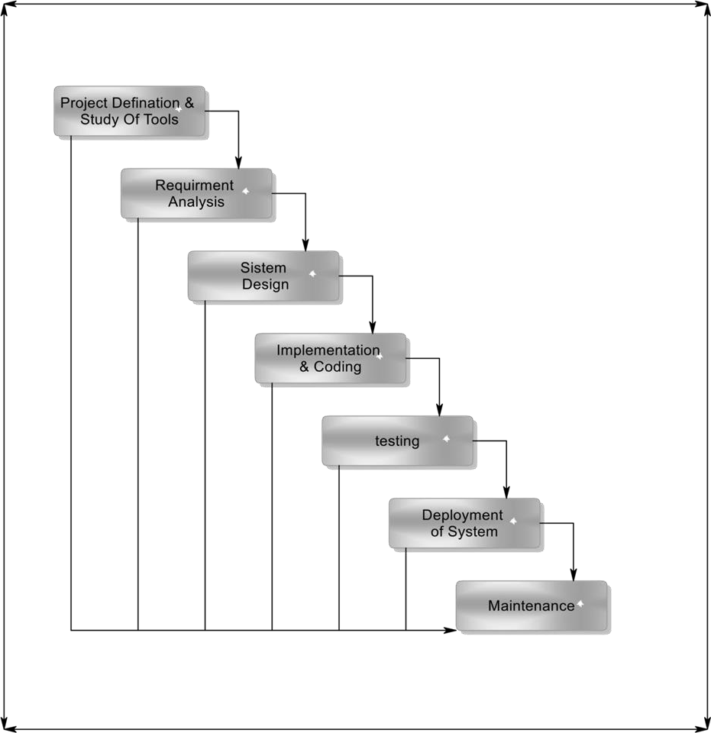

* + 1. Project Definition & Study of Tools:-
* This project about online photo shoot booking.
* Customer can book an order from home for the diagnosis of their illness on our website.
  + 1. Requirement Analysis: -
       - The requirements gathering process makes stronger and focused specifically on business activities understanding requirement, an analyst can have clear idea about the nature of the software including function behavior, performance and interface requirements for the system recorded and evacuated with the user.
    2. System Design: -
       - **Software design shows following four distinct components of a program.**
         * Database design
         * Software architecture
         * Interface design
         * Algorithm
       - The process converts requirements into a symbolic representation of the software that can be used for static testing before coding like requirement the design is documented and turns out to be part of the software configuration.
    3. Implementation & Coading:-
       - The design must be converted into a machine, program the code generation step done this task.If design is performed in a correctly code generation can be done speedy and with more efficiency.
    4. Testing:-
       - Once code developed program testing can be started. The testing process covered by static and dynamic way. It also covers structure and functional testing. For quality testing also covers non-functional requirements.
    5. Deployment of Syatem:-
       - Once the functional and non-functional testing is done the product deployed in the customer environment or released in to the market.
    6. Maintenance:-
       - There are some issues which come up in the client environment to fix those issues patches are released maintenance is done to deliver these changes in the customer environment.
  1. Project Scheduling: -
* Project scheduling is corned with the techniques that can be employed to manage the activity that need to be undertaken during the development of a project.

|  |  |  |  |
| --- | --- | --- | --- |
| **No.** | **Activity** | **Starting Date** | **Completion Date** |
| 1 | Requirement analysis | 15 Dec | 25 Dec |
|  |  |  |  |
| 2 | System analysis | 26 Dec | 5 Jan |
|  |  |  |  |
| 3 | Project planning & scheduling | 6 Jan | 20 Jan |
|  |  |  |  |
| 4 | System design & form design | 21 Jan | 30 Jan |
|  |  |  |  |
| 5 | Coding & implementation | 31 Jan | 9 Feb |
|  |  |  |  |
| 6 | Testing | 10 Feb | 19 Feb |
|  |  |  |  |
| 7 | Documentation | 20 Feb | 25 Feb |

* + 1. Gantt Chart & Timeline Chart:-

|  |  |  |  |  |  |  |  |
| --- | --- | --- | --- | --- | --- | --- | --- |
| **Task date & name** | **15Dec To 25Dec** | **26Dec To**  **5Jan** | **6Jan To 20Jan** | **21Jan To 30Jan** | **31Jan To 9Feb** | **10Feb To 19Feb** | **20Feb To**  **25Feb** |
| **Requirement Analysis** |  |  |  |  |  |  |  |
|  |  |  |  |  |  |  |  |
| **System Analysis** |  |  |  |  |  |  |  |
|  |  |  |  |  |  |  |  |
| **Project Planning &**  **Scheduling** |  |  |  |  |  |  |  |
|  |  |  |  |  |  |  |  |
| **System Design & Form**  **Design** |  |  |  |  |  |  |  |
|  |  |  |  |  |  |  |  |
| **Coding Implementation** |  |  |  |  |  |  |  |
|  |  |  |  |  |  |  |  |
| **Testin** |  |  |  |  |  |  |  |
|  |  |  |  |  |  |  |  |
| **Documentation** |  | | |  |  |  |  |

1. **FEASIBILITY STUDY**

* The initial investigation points to the question whether the project is feasible a feasibility is conducted to identity the best system that meets the all the requirements this includes an identification description and evaluation of the proposed system and selection of the best system for the job.
* The requirement of the system is specified with a set of constraints. Such as system objective and the description of the output. If is then duty of the analyst to evaluate the feasibility of the proposed system to generate the above results.
  1. Gantt Chart & Timeline Chart:-
     + Technical current of technology supports the proposed system. The current setup is sufficient for the processing of the kind tasks.
     + Management agreed to purchase extra devices for latest technology if necessary.
     + The software needed to important and execute the system are already existing.
     + Technical analysis evaluation technical merits of the system at the same time collecting additional information about performance, reliability, maintainability and productivity.
  2. Operational Feasibility:-
     + The proposed system will fulfill the company’s quarrymen.
     + The proposed system covers all aspect of the current Manual system.
     + The human sources required number of staff operationally for the company.
     + Proposed system is helpful for all the users associated with the organization.
     + The decision making process of their will also become faster with the use of data integration, consolidation so it is feasible to implement the system
  3. Social Feasibility:-
     + Social feasibility addresses the influences that a proposed project may have on the social system in the project environment
     + It should be recognized that workers in certain industries may have certain status system within the society.
     + The ambient social structure may be such that certain categories of workers may be in short supply or non-existent.
  4. Organizational Feasibility:-
     + I have organizational feasibility as meaning whether the new system will fit in to the organization and meet the current goals and objectives.
     + This involves questions such as whether the system has enough support to be implemented successfully whether it brings an excessive amount of change and whether the organization is changing two rapidly to it.

**Two of important factors in this are: -**

* + - * The passion that the sole entrepreneur or management team has for the business idea.
      * The extent to which the management team or sole entrepreneur understand the markets in which the firm will participate.
  1. Economic Feasibility:-
     + Economic feasibility is the most important and frequent used method for evaluating the effectiveness of the proposed system.
     + It is very essential the main goal of the proposed system is to have economically better result along with increased efficiency cost benefit analysis is usually performed for the purpose.
     + It is the comparative study of the cost versus the benefit and savings that are expected from the proposed system, since the organization is well equipped with the organization is well equipped with the required hardware the project was found to be economically.

**Cost Estimation**

* Working the estimation is given:
* 3Months and 3 days =95days
* Hours 1 days = 95*4=380/24 = 16days
* Now, the expense & cost estimation

|  |  |
| --- | --- |
| Light Bill | 5000 |
| Energy charge | 4000 |
| Database design | 4000 |
| Coding | 3000 |
| Internet connection | 6000 |
| Extra activity | 5000 |
| Total | **27000 Rs.** |

1. **DATABASE DESIGN**
   1. User case diagram: -

**User :-**



User

Register

Login

Gallary

Services

Contact

**Admin :-**



Admin

Login

User Info

Insert, Update, Delete

Booking Info

Contact Info

* 1. DFD diagram: -
     + Data is the life blood of any system. Diagram of flow of data in system and its processing which converts data into valuable information in known as data flow diagram. It will not show logic of the algorithm its shows only flow of the data from the process to the process or from the table or from external source to the external source to the external destination.

1. **Data Process :**
2. **Data Store :**
3. **External interaction :**
4. **Dynamic Connector :**

5.2.1 DFD:- Level - 0 :-



Request

Show

User

Response

The Perfect Studio

Request

Admin

Level – 1 User:-



Reistration

User

Register

Response

Register

Login

Response

Login

View Data

Services

Response

View Services

Order

Response

Booking

Contact

Response

Contact

Enter Data

Enter Data

Login Success

Level - 2 Admin:-



Reistration

Admin

Home

Response

Show Home

Insert, Update, Delete Services

Response

Add Category

View Data

User Info

Response

Register

Order

Response

Booking

Contact Info

Response

Message

View Data

View Data

Enter Data

* 1. Class diagram: -

1 M

|  |
| --- |
| Register |
| Id : int  Username : varchar(50) Email : varchar(50) Contact : varchar(50) City : Varchar(50) Address : Varchar(50) Password : Varchar(50) |
| Insert, Update, Delete |

|  |
| --- |
| Contact |
| Id : int  Username : varchar(50) Email : varchar(50) Subject : varchar(50)  Message : Varchar(50) |
| Insert, Update, Delete |

|  |
| --- |
| Order |
| Id : int  Username : varchar(50) Email : varchar(50) Contact : varchar(50) Address : Varchar(50) Services : Varchar(50) Date : Varchar(50)  Day : Varchar(50) Location : Varchar(50) Shooting : Varchar(50) Package : Varchar(50)  Amount : Varchar(50) |
| Insert, Update, Delete |

1

M

M

1

**Admin**

**User**

|  |
| --- |
| Services |
| Id : int  Main_cat : varchar(50) Locatuon : varchar(50) Detail : varchar(50) Photo_p : Varchar(50) Video_p : Varchar(50)  Cinematic_video : varchar(50) Album_p : Varchar(50)  Image : Varchar(100) |
| Insert, Update, Delete |

* 1. Data dictionary:-
     + The Data Dictionary can be specifically defines as an exhaustively organized list Of all data elements that are pertinent to the system with precise, rigorous understanding Of inputs and outputs and the components of stores along with all the constraints and Intermediate calculations.
     + In other words, a data dictionary is a catalogue – a repository of element in a System. Here in a data dictionary one can find list of all the elements composing the data flowing through a system. The major elements are data flows, data stores and process. The data dictionary stores the details and description of all these elements.

**Importance of Data Dictionary:-**

* + - * To manage the details in large system.
      * To communicate a common meaning for all system elements.
      * To document the features of a system. To facilitate analyst for the details in order to evaluate system requirements**.**

**Following is the list of Tables which are used in my project. Consider Following Data Dictionary Which denotes Tables detail.**

Table:-1 [Register] Table:-2 [Services] Table:-3 [Order] Table:-4 [Contact]

Table 1 :- Registration

|  |  |
| --- | --- |
| **Fieldname** | **Data Type** |
| Id | int |
| Username | varchar(50) |
| Email | varchar (50) |
| Contact | varchar (10) |
| City | varchar (50) |
| Address | varchar (50) |
| Password | varchar(50) |

Table 2 :- Services

|  |  |
| --- | --- |
| **Fieldname** | **Data Type** |
| Id | int |
| Service | Varchar(50) |
| Location | Varchar (50) |
| Detail | Varchar (10) |
| Photo_p | Varchar (50) |
| Video_p | Varchar (50) |
| Cinematic_video | Varchar(50) |
| Album_p | Varchar(50) |
| Image | Varchar(50) |

Table 3 :- Order

|  |  |
| --- | --- |
| **Fieldname** | **Data Type** |
| Id | int |
| Username | Varchar(50) |
| Email | Varchar (50) |
| Contact | Varchar (10) |
| Address | Varchar (50) |
| Service | Varchar (50) |
| Date | Varchar(50) |
| No Of Day | Varchar(50) |
| Location | Varchar(50) |
| Shooting | Varchar(50) |
| Package | Varchar(50) |
| Amount | Varchar(50) |

Table 4 :- Contact

|  |  |
| --- | --- |
| **Fieldname** | **Data Type** |
| Id | int |
| Username | varchar(50) |
| Email | varchar (50) |
| Subject | varchar (50) |
| Message | varchar (100) |

Normalization:-

1. **DATABASE NORMALIZATION**
   * Normalization is the first step to design any database.
   * Normalization is a database design techniques which organizes tables in a member that reduces redundancy and dependency of data.
   * There are three types of normalization:-
     + 1NF
     + 2NF
     + 3NF

Unnormalization:-

|  |  |  |  |
| --- | --- | --- | --- |
| Id | Service | Package | Subject |
| Username | Location | Date | Message |
| Email | Detail | Day | Cinematic_video |
| Contact | Photo_p | Amount | Album_p |
| City | Video_p | Address | Image |
| Password |  |  |  |

**1NF:-**

* 1NF means first Normalization form.
* There are two rules of 1NF.
* First create a separate table for each set of related data.
* Identify each set of related data with a primary key.
* All attributes are single values and non-repeating.

Table 1 :- Registration

|  |  |
| --- | --- |
| **Fieldname** | **Data Type** |
| Id | int |
| Username | varchar(50) |
| Email | varchar (50) |
| Contact | varchar (10) |
| City | varchar (50) |
| Address | varchar (50) |
| Password | varchar(50) |

Table 2 :- Contact

|  |  |
| --- | --- |
| **Fieldname** | **Data Type** |
| Id | int |
| Username | varchar(50) |
| Email | varchar (50) |
| Subject | varchar (50) |
| Message | varchar (100) |

Table 3 :- Services

|  |  |
| --- | --- |
| **Fieldname** | **Data Type** |
| Id | int |
| Service | Varchar(50) |
| Location | Varchar (50) |
| Detail | Varchar (10) |
| Photo_p | Varchar (50) |
| Video_p | Varchar (50) |
| Cinematic_video | Varchar(50) |
| Album_p | Varchar(50) |
| Image | Varchar(50) |

Table 4 :- Order

|  |  |
| --- | --- |
| **Fieldname** | **Data Type** |
| Id | int |
| Username | Varchar(50) |
| Email | Varchar (50) |
| Contact | Varchar (10) |
| Address | Varchar (50) |
| Service | Varchar (50) |
| Date | Varchar(50) |
| No Of Day | Varchar(50) |
| Location | Varchar(50) |
| Shooting | Varchar(50) |
| Package | Varchar(50) |
| Amount | Varchar(50) |

**2NF:-**

* 2NF means second normal form.
* Create separate table for sets of values that apply to multiple records.
* Relate the tables with a foreign key.
* 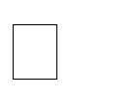Records should not depend on anything other than a table’s primary key. Meet all the requirements the first normal form.
* Create relationship between these new table and their pre decessors through the use of foreign keys.
* Remove subset of data that apply to multiple rows of a tables and place them separate table.

Table 1 :- Registration

|  |  |  |
| --- | --- | --- |
| **Fieldname** | **Data Type** | **Constraint** |
| Id | int | Primary Key |
| Username | varchar(50) |  |
| Email | varchar (50) |  |
| Contact | varchar (10) |  |
| City | varchar (50) |  |
| Address | varchar (50) |  |
| Password | varchar(50) |  |

Table 2 :- Services

|  |  |  |
| --- | --- | --- |
| **Fieldname** | **Data Type** | **Constraint** |
| Id | int | Primary Key |
| Service | Varchar(50) |  |
| Location | Varchar (50) |  |
| Detail | Varchar (10) |  |
| Photo_p | Varchar (50) |  |
| Video_p | Varchar (50) |  |
| Cinematic_video | Varchar(50) |  |
| Album_p | Varchar(50) |  |
| Image | Varchar(50) |  |

Table 3 :- Order

|  |  |  |
| --- | --- | --- |
| **Fieldname** | **Data Type** | **Constraint** |
| Id | int | Primary Key |
| Username | Varchar(50) |  |
| Email | Varchar (50) |  |
| Contact | Varchar (10) |  |
| Address | Varchar (50) |  |
| Service | Varchar (50) |  |
| Date | Varchar(50) |  |
| No Of Day | Varchar(50) |  |
| Location | Varchar(50) |  |
| Shooting | Varchar(50) |  |
| Package | Varchar(50) |  |
| Amount | Varchar(50) |  |

Table 4 :- Contact

|  |  |  |
| --- | --- | --- |
| **Fieldname** | **Data Type** | **Constraint** |
| Id | int | Primary Key |
| Username | varchar(50) |  |
| Email | varchar (50) |  |
| Subject | varchar (50) |  |
| Message | varchar (100) |  |

**3NF:-**

* 3NF means third normal form.
* Eliminate fields that do not depend on the primary key.
* Each non-primary key attributes must be dependent only on primary key.

Table 1 :- Order

|  |  |  |
| --- | --- | --- |
| **Fieldname** | **Data Type** | **Constraint** |
| Id | int | Primary Key |
| Username | Varchar(50) |  |
| Email | Varchar (50) |  |
| Contact | Varchar (10) |  |
| Address | Varchar (50) |  |
| Service | Varchar (50) |  |
| Date | Varchar(50) |  |
| No Of Day | Varchar(50) |  |
| Location | Varchar(50) |  |
| Shooting | Varchar(50) |  |
| Package | Varchar(50) |  |
| Amount | Varchar(50) |  |

**7.SCREEN SHORT**

User Side :-

**Home**

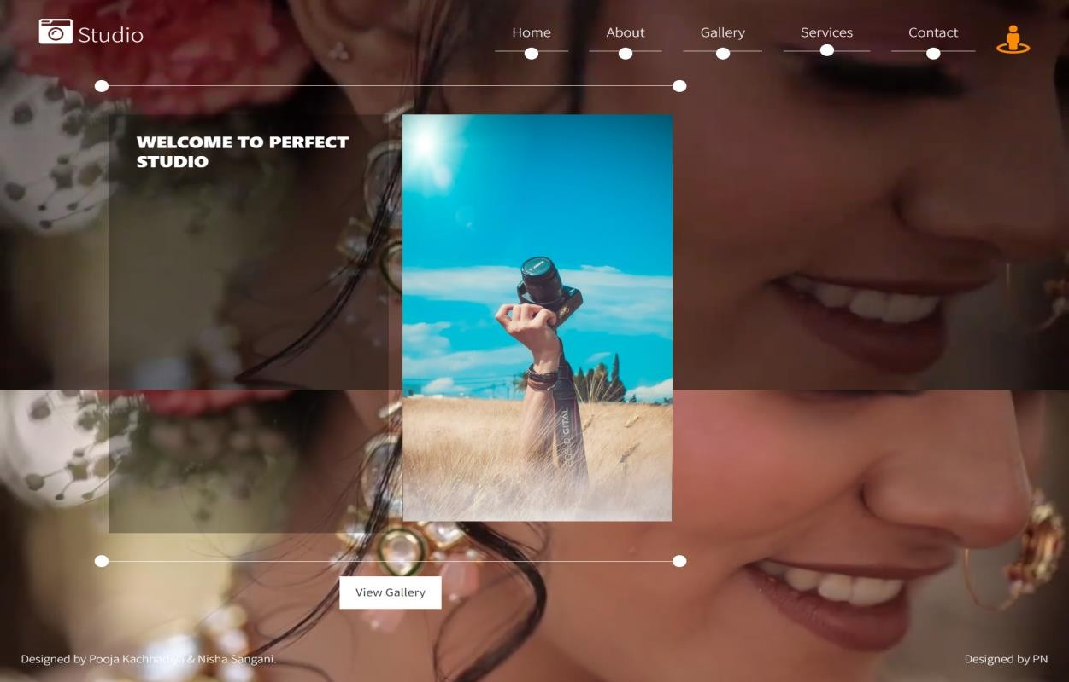

**About :-**

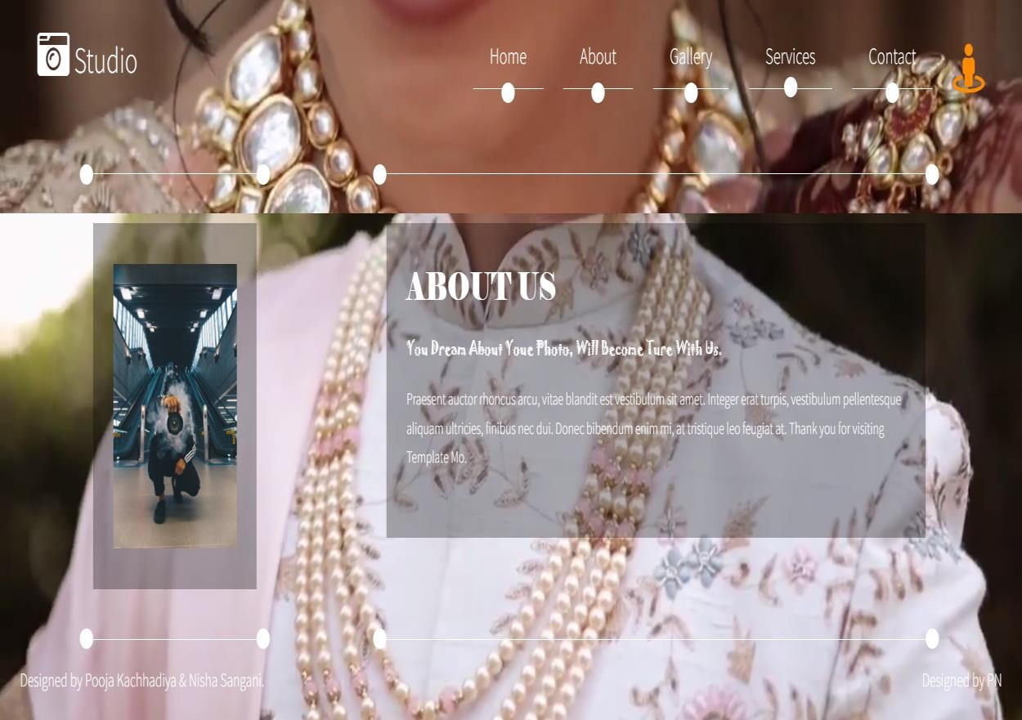

**Gallery**

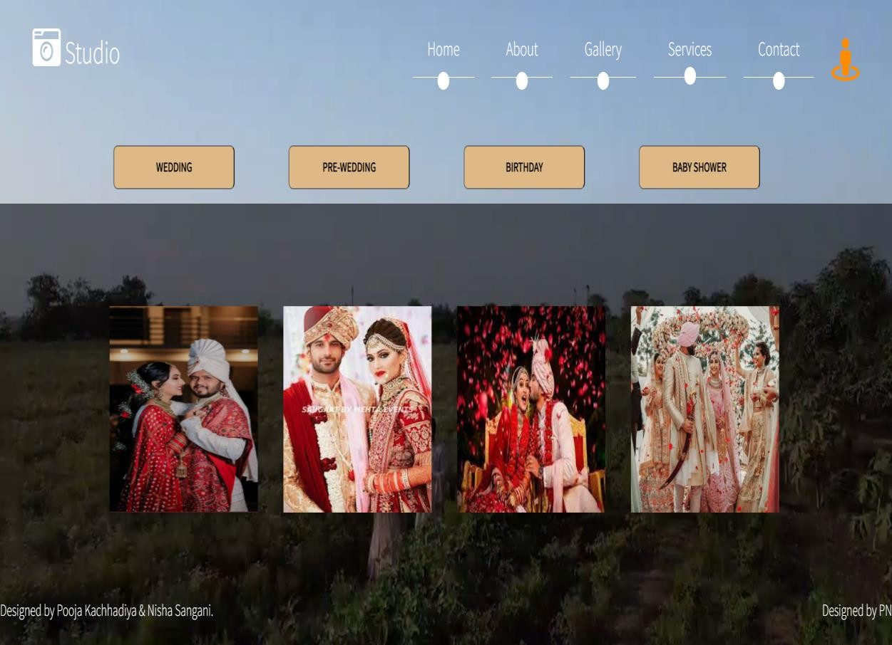

**Services**

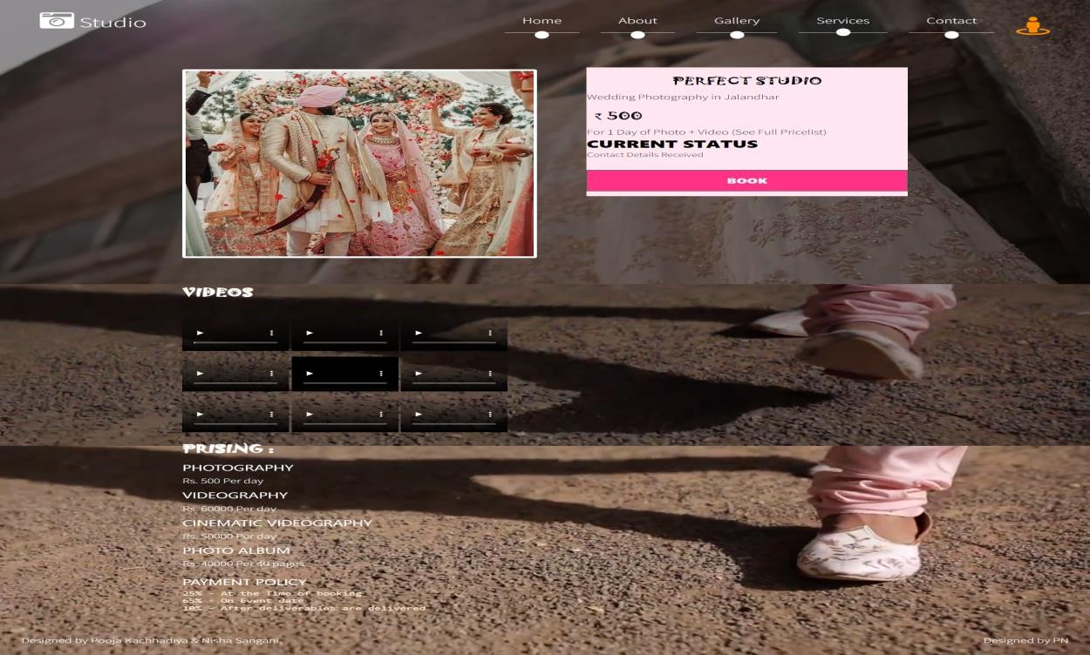

**Order**

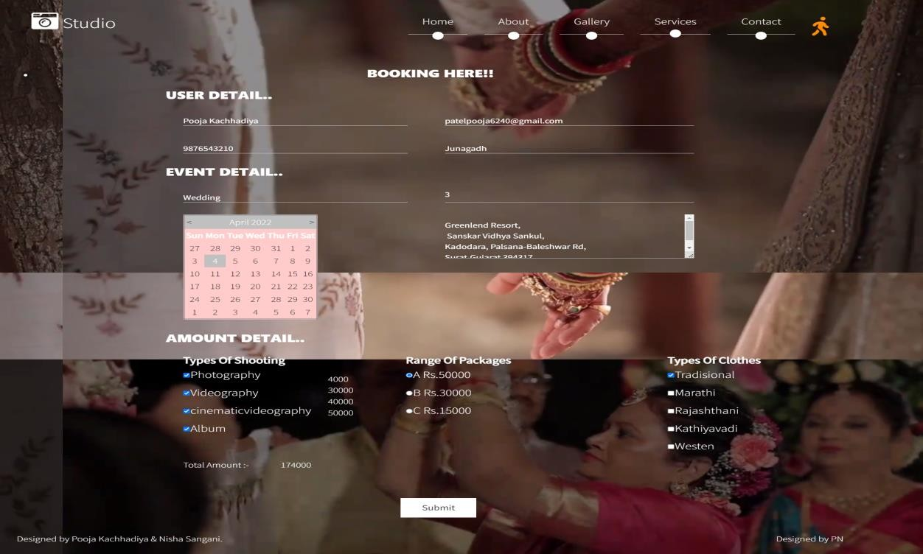

**Contact :-**

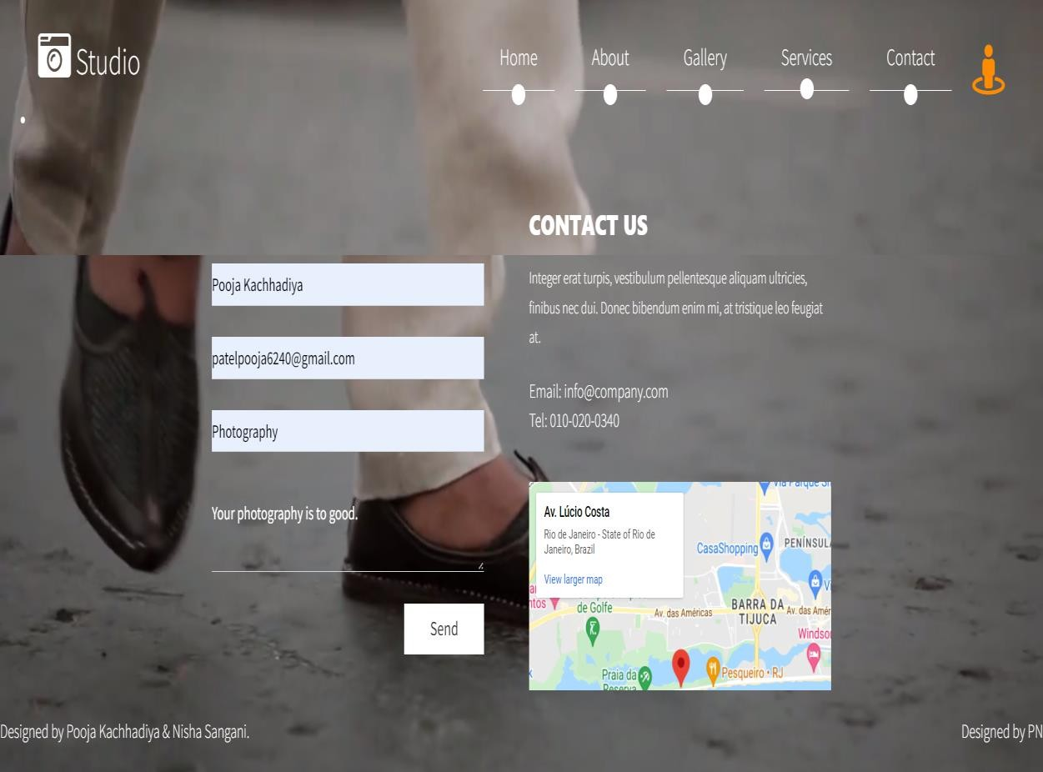

Admin Side:-

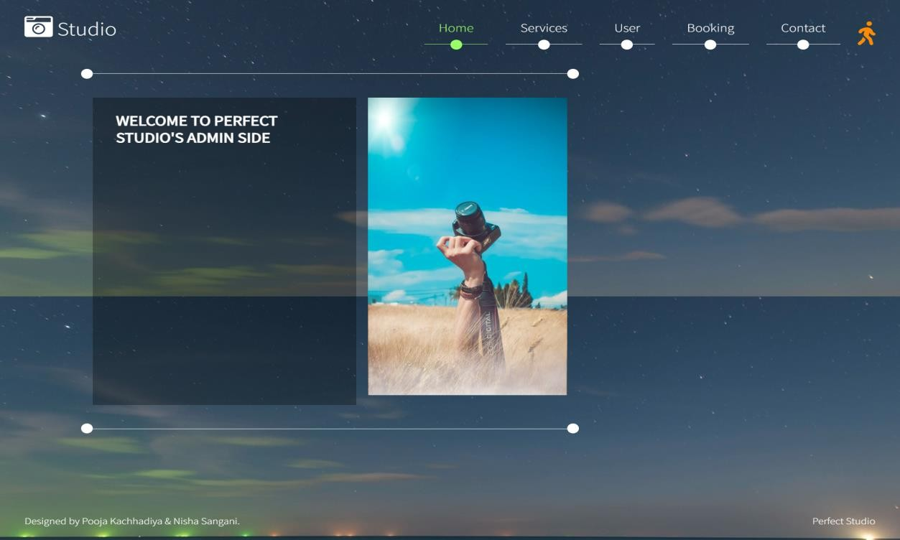Home

User Info

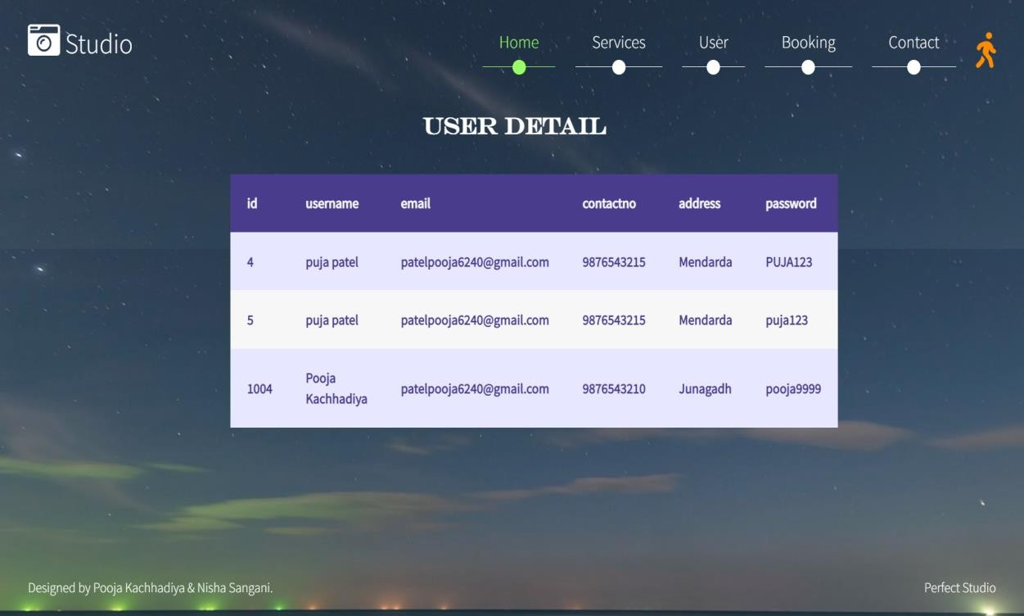

Services

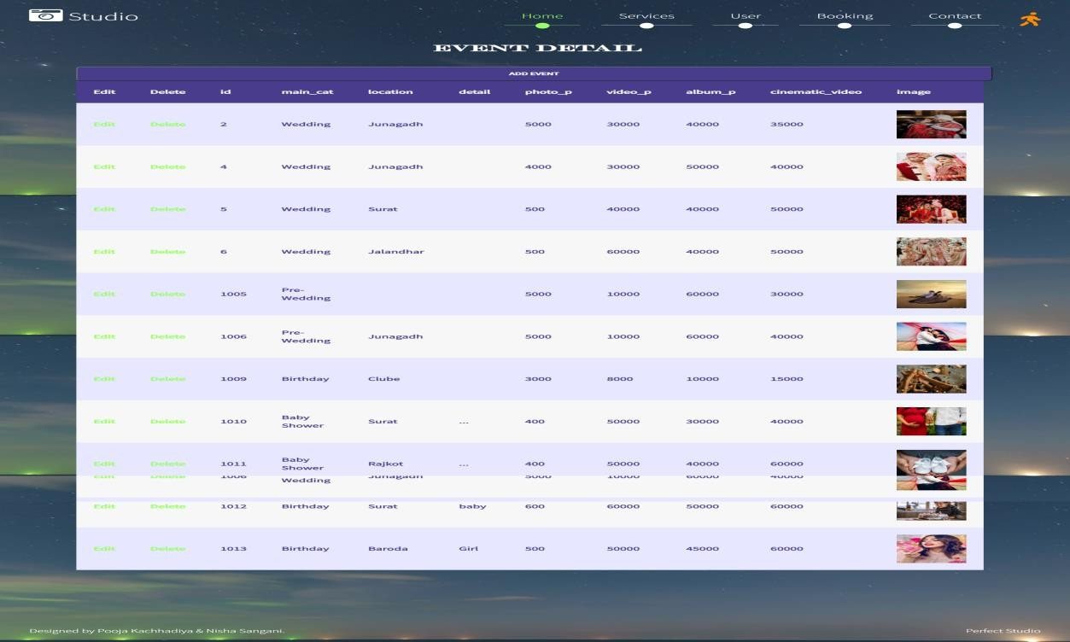

Order

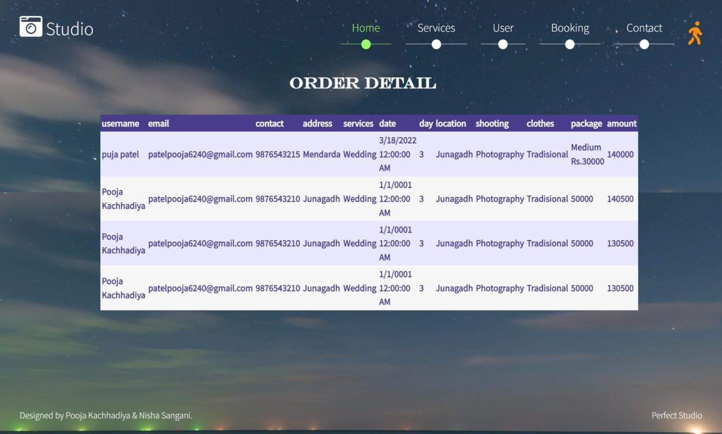

1. **SOFTWARE TESTING**

* Software testing in values the executing of a software component or system Component of evaluates one or more properties of interest.
* Meet the requirements that guided its design the development. Responds correctly to All kinds of inputs. Perform its function wither on acceptable time. Is sufficiently usable.
  1. Types of Testing :-
     1. White Box Testing
     2. Black Box Testing
     3. Validation Testing
     4. Alpha
     5. Beta
     6. Manually
     7. White Box :-



Test Data

Derives

Component Code

Test Output

* As per our project, we have used white box testing model because independent Of PHP file and loop are the cornerstones of the vast majority of all algorithms implemented in the software.
* White box testing sometime called glass box testing, where test data are derived from Direct examination of the code to be tested.
* For glass box testing the test case cannot be determined until the code has actually Been written both of these testing techniques have advantages and disadvantages, but when Combined, they help to ensure thorough testing of the product.
  + 1. Black Box Testing :-

Input coursing



Black Box Testing

i.e.

System

Output

o.e.

Output with reveal

* It takes an external perspective of the test object to derive test cases. These tests can Be functional or non-functional, though usually functional.
* The test designer selects valid and invalid input and determines the correct output.
  + Interface errors.
  + Errors data structures or external data base access.
  + Behavior or performance errors.
  + Intilization and termination error.
    1. Validation Testing :-
* In validation testing, the software is assembling as a package. Validation testing is Completely associated with requirement satisfaction of customers. According to this test, the Project is tested and found to be satisfactory for functional characteristic, behavioral Characteristics and performance requirement.
  + 1. Alpha :-
       - Alpha is the first letter of the Greek alphabet. In the system of Greek numerals it has Value of 1. It was derived from the Phoenician letter alpha.
       - Letter’s that arose from alpha include the Latin A and Cyrillic letter A. in English, the Noun “Alpha” is used as a synonym for “beginning”, or “first”, reflecting its Greek roots.
    2. Beta :-
* Beta is the second latter or the Greek alphabet. In system of Greek numeus it has valued of ancient Greek, beta represented the voiced bilabial plosive. In modem Greek it represents the voice labiodentals fricative. Letters that arose from beta include the Roman letter (B) and Cyrillic letter (5) and (B).
  + 1. Manual :-
* We have done manual testing for over project all the Webpages validation, redirection, navigation are manually test by as.
  1. Test Strategy :-
* A test strategy is an outline that describe testing approach of the software development cycle.
* It is created to inform project manages, testers, and developers about some key issues of the testing objective, methods of testing new functions, total time And resources required for the project, and the testing environment.
* Design document describe the functionality of the software to be enabled in the up coming release’s corresponding test strategy should be created to test the new Feature sets.
  1. Test Case :-
* A test case is a set of conditions or variable under which a tester will determine whether a system under test satisfies requirements or works correctly. The process of developing test case can also help find problems in the requirements or design of an application.

1. Formal test case.
2. Informal test case.
3. Typical written test case.
4. Error handling
   * 1. Formal Test Case :-

* The formal test case is order to fully test that all the requirements of an Application are met, there must be at least two test cases for each requirement positive Test and one negative test.
* If a requirement has sub- requirements, each requirement must have at least two Test cases.
* A formal test-case is characterized by a known input and by an expected Output, which is worked out before the test is executed.
  + 1. Informal Test Case :-
* Information is valuable because it can affect behavior, a decision, or an Outcome.
* For example, if a manager is told her company’s net profit decreased in the past Month, he may use this information as a reason to cut financial spending for the next Month.
* A piece of information is considered valueless if, after receiving it, things remain unchanged. For a technical definition of information see information theory.
  + 1. Typical Test Case :-
* A test case is usually a single step, or occasionally a sequence of steps, to test the correct behavior/functionally, features of an application.an expected result or Expected outcome is usually given.
* A written test case should also contain a place for the actual result. The larger Test case may also contain prerequisite states or steps, and descriptions.
* These steps can be stored in a word processor document, spreadsheet, and database or other common repository

**Additional information that may be included.**

* + Test case id
  + Test case description
  + Test case step or order or exception number
  + Related requirement
  + Depth
  + Text category
  + Author
  + Pass/failed
  1. Error Handling :-

**ERROR: -** Other function are used.

**SOLUTION: -** Used eval function.

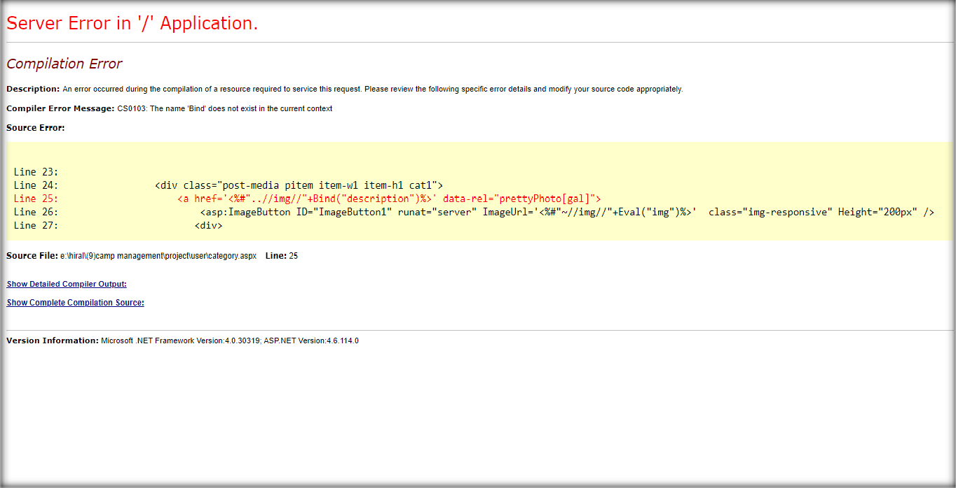

1. **PROJECT IMPLEMENTATION PLANNING**

* Implementation simply means carrying out the activities description in your Work plan. Executing a project in the water and sanitation sector is a very complex mission, as it requires the coordination of a wide range of activities the overseeing if a team, the management of budget, the communication to the public, among other Issues.
* Project implementation is the phase where visions and plans become reality. This is the logical, conclusion, after, evaluating, deciding, visioning, planning, applying for funds and finding the financial resources of a project.
  1. User of function :-
     + A user define function is a programmed routine that has its parameters set by the user of the user of the system.
     1. Admin :-
* Admin is the heart of any application. In this project admin can view and manage all the details about the institute. The most important facility is to manage the input validation.
* Another thing is that, material update, delete by the admin and add tricks so user cannot make any change in profile details. This makes the database secure and reliable.
  + 1. User :-
* User an individual who uses as computer. This includes expert programmer as well as Novice.
* An end user is any individual who runs an application program.
* User can login in the application with user id, password given after the registration.
  1. Security Features:-
     + Security is an important aspect of any software components, without reasonable level Of security, the availability, the reliability and safety may be compromised if external attack Causes some damage to the system.
     + As our application web-based so network security is an aspect which should be Provided by the servers where the application is deployed.
     + Email id and password should not accessible by any other user. Only administrator Can delete users.
     + Session is created as the user login and session is checked in all the modules.
     + Session destroyed after the user logout to application.
  2. Coding Standards:-
     + 2 tier architecture used for coding which makes the functionality easy error face, easy modification.
     + The coding standard is the well-defined and standard style of coding with the help of the coding standard any person can go into any code and figure out what’s going on and new people can get up to speed quickly. A coding standard’s ways of doing several things such as the way variable are to be named the code is to be a id the comments are to be described, the work of function are to carried out etc.



Presentation Layer

Business Logic Layer

Data Access Layer

Data Source

* + - The entire query is written as a store procedure which is separately stored for further modification.
    - Make a property file for all Queries. This will help in changing query easily without changing you. Java files. Queries can also be reused.
    - Data source is physical storage space where they actually data stored.
    - Connection is established in web.config file, developer doesn’t require making connection in the entire file, just have to call the connection string of web.config file.
    - Keep few variables at class level along with frequently used DAO and Property files. Make proper usage of CSS files. Use standard Style Class defined in CSS except for exceptional cases.
    - Write proper comments in all files for easy maintenance and understanding. Changes in the files made should also be maintained.

1. **LIMITATION & FUTURE ENHANCEMENT**
   1. Limitation :-
      * Gives you a limit on the scenes and background of the photographs.
   2. Feature Enhancement :-
      * Silhouette images are created using backlighting. Position your subject in front of a strong light source, with no light coming from behind your camera.
2. **CONCLUSION**
   * + The project entitled “The Perfect Studio” is developed using asp.net as font end sql server database in back end to computerize the process of online order booking of photography in a studio. This project covers only the basic features required.
     + Online Photoshoot Booking Service is the solution for the current 'online generation' as it save the time and effort. Plus it’s a boost for casual photoshoots an increasing the market for the casual photographers.
     + Its saves the money as well because of the competition the platform allowing it to boom. As the rime goes by various photographer from India will enroll and save the cost of calling photographer from far thus decreasing the price to a great amount and increasing the demand. Day by day the photography industry will grow more gadgets would become cheaper and will have a small contribution towards it.
3. **BIBLIOGRAPHY**

**Reference book:-**

* Nirav Prakashan Web Developing Using Asp.net

**Website:-**

*[www.w3school.com](http://www.w3school.com/)